**Business rules**

As you have been learning, a business rule is a statement that creates a restriction on specific parts of a database. These rules are developed according to the way an organization uses data. Also, the rules create efficiencies, allow for important checks and balances, and also sometimes exemplify the values of a business in action.  For instance, if a company values cross-functional collaboration, there may be rules about at least 2 representatives from two teams checking off completion on some data set. They affect what data is collected and stored, how relationships are defined, what kind of information the database provides, and the security of the data. In this reading, you will learn more about the development of business rules and see an example of business rules being implemented in a database system.

**Imposing business rules**

Business rules are highly dependent on the organization and their data needs. This means business rules are different for every organization. This is one of the reasons why verifying business rules is so important; these checks help ensure that the database is actually doing the job you need it to do. But before you can verify business rules, you have to implement them.

For example, let’s say the company you work for has a database that manages purchase order requests entered by employees. Purchase orders over $1,000 dollars need manager approval. In order to automate this process, you can impose a ruleset on the database that automatically delivers requests over $1,000 to a reporting table pending manager approval. Other business rules that may apply in this example are: prices must be numeric values (data type should be integer); or for a request to exist, a reason is mandatory (table field may not be null).

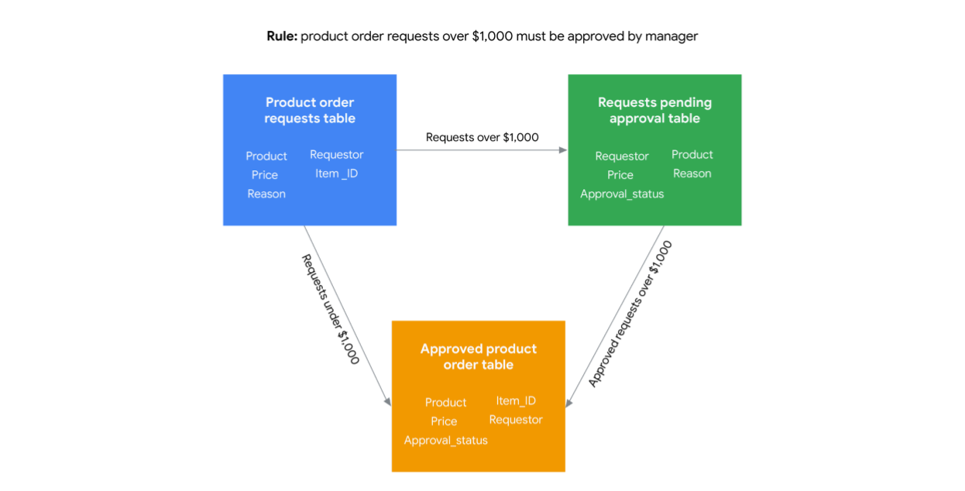

In order to fulfill this business requirement, there are three rules at play in this system:

1. Order requests under $1,000 are automatically delivered to the approved product order requests table
2. Requests over $1,000 are automatically delivered to the requests pending approval table
3. Approved requests are automatically delivered to the approved product order requests table

These rules inherently affect the shape of this database system to cater to the needs of this particular organization.

**Verifying business rules**

Once the business rules have been implemented, it’s important to continue to verify that they are functioning correctly and that data being imported into the target systems follows these rules. These checks are important because they test that the system is doing the job it needs to, which in this case is delivering product order requests that need approval to the right stakeholders.

**Key takeaways**

Business rules determine what data is collected and stored, how relationships are defined, what kind of information the database provides, and the security of the data. These rules heavily influence how a database is designed and how it functions after it has been set up. Understanding business rules and why they are important is useful as a BI professional because this can help you understand how existing database systems are functioning, design new systems according to business needs, and maintain them to be useful in the future.